Type the Main Title of the Paper

- Type the Subtitle of the Paper -

**Main author’s Name 1)  Co-author’s Name 2)**

*1) Society of Automotive Engineers, Inc., Chiyoda, Tokyo, Japan*

*E-mail: taro@jsae.or.jp*

*2) JSAE University, Graduate School of Engineering, Chiyoda, Tokyo, Japan*

*E-mail: taro@jsae.or.jp*

**ABSTRACT**: This paper is sample of **extended summary and final paper**. **The minimum page of the extended summary is 2 and the maximum page is 4. At least one figure is necessary on this paper. The minimum page of the final paper is 4 and the maximum page is 8.** Font size of main title is 16 point, sub-title is 11 point, author’s name is 11 point and author’s affiliation is 9 point and abstract is 9 point. Top and bottom margin are 25 mm and side margin are 18 mm. Chapter font size is 9 point. Text font size is 9 point and two columns in which the margin between columns is 8 mm. Keywords font size is 9 point and there are categories.

**KEY WORDS**: electric vehicle, lithium-ion battery, power electronics, wireless power transfer, motor, powertrain, fuel cell

**1. Introduction**

Font size for context is 9 point. Clearly describe the purpose, contents, and conclusion of the research, while complying with the ethical guidelines of the JSAE. Company and product names, terminology whose usage is restricted to within a particular company, and commercial content may not be included in the main text.

Note for “References” is indicated in “REFERENCES” as below.(1)

**2. SECTION TITLE**

**2.1. Subheading**

Clearly describe the purpose, contents, and conclusion of the research, while complying with the ethical guidelines of the JSAE. Company and product names, terminology whose usage is restricted to within a particular company, and commercial content may not be included in the main text.

**2.2. Subheading**

Type the contents of the section here.

**2.2.1. Sub-subheading**

Type the contents of the section here.

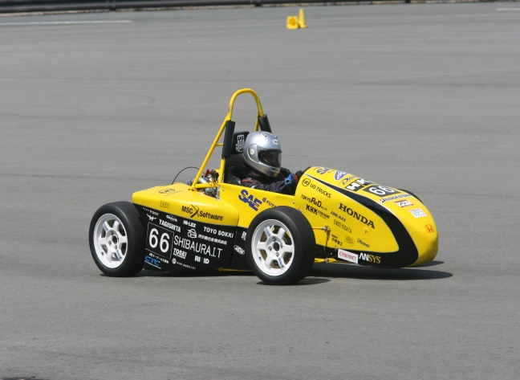

Fig. 1 Type the Caption Here. Font size is 9 point.

**3. SECTION TITLE**

Here is for section 3 contents.

Table 1 Type the Caption Here. Font size is 9 point.





Fig.2 A Bar Graph

**4. CONCLUSION**

Type the contents of the conclusion here.

**ACKNOWLEDGMENT**

Here is for acknowledgement.

**References**

(1) A. Author, B. Author, and C. Author, “Title of Journal or Transaction Paper,” *Name of Journal or Transactions*, vol. 5, no. 12, pp. 12-15, May 2017.

(2) A. Author and B. Author, “Title of Paper in Conference Proceedings,” *Name of Conference Proceedings*, pp. 12-15, Yokohama, Japan, May 25-27, 2016.

(3) A. Author, *Title of Book*, Name of Publisher, 2018.

(4) C. Author. “Title of Website.” Name of Organization. https://www.jsae.or.jp/en/ (accessed May 25, 2020).

(5)

(6)

(7)

(8)

(9)

(10)

(11)

(12)

(13)

(14)

(15)

(16)

(17)

(18)

(19)

(20)