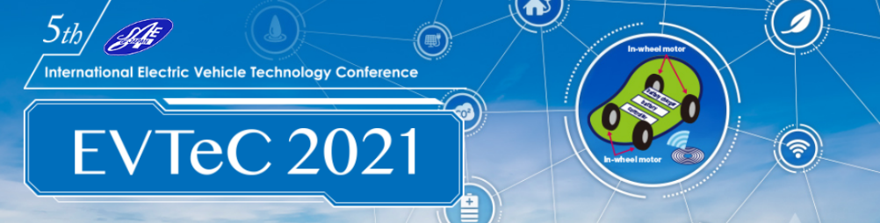

Application Deadline:
March 19, 2021

EVTeC 2021 - Sponsorship Application

I hereby apply to the following sponsorship option.
Please check the option you will apply for
☐ Gold Sponsorship (700,000 JPY)
☐ Silver Sponsorship (350,000 JPY)
☐ Advertising Option (100,000 JPY)

Name of Organization
Person Responsible: | (fill in the blanks below)
Name
Section
E-mail Address
Phone
Fax (if available)
Postal Address

An invoice will be issued after the application details have been confirmed and accepted. Due date of payment will be indicated after the confirmation of the sponsorship.
We will contact you with the details regarding the data needed after the sponsorship has been confirmed.

Send to:
Hisataka Sakurai (Mr.)
Secretariat of EVTeC 2021Steering Committee, Society of Automotive Engineers of Japan, Inc.
Mail: sakurai@jsae.or.jp / Phone: +81 3 3262 8235

